**.Net Technology (01CE0602)**

**Department of Computer Engineering**

**6th Semester**

**Lab Manual**

**(Year: 2022-23)**

**Index**

|  |  |  |  |
| --- | --- | --- | --- |
| **Lab** | **Programs** | **Date** | **Signature** |
| 1 | a. Write a C# Program to print “Hello World”.  b. Write a C# Program to add 2 Numbers.  c. Write a C# Program to find maximum of 2 Numbers.  d. Write a C# Program to generate electricity bill using Else-If ladder.  e. Write a C# Program to find the sum of first N numbers. |  |  |
| 2 | a. Write a C# Program to check a number is Palindrome or not.  b. Write a C# Program to generate Fibonacci series up to N Numbers.  c. Write a C# program to create a calculator using Switch Case.  d. Write a C# Program to print a given array in reverse.  e. Create a simple C# code for the following:  55555  4444  333  22  1 |  |  |
| 3 | a. Write a C# program find area of Circle, Rectangle and Square using Polymorphism.  b. Consider a class Information that has data members as Name, Surname and Contact number. Let Employee and Student class inherits Information class with its own other information such as Students Semester or Employee Salary. Implement a system using Method Overriding to take input from the user for all the information and display proper output.  c. Consider a class Apartment that has data members as Apartment number and balcony type. Implement a system that has 3 classes as 1bhk, 2bhk and 3bhk such that it does not allow to create any other classes above 3bhk. Also implement inheritance in such a way that 1bhk will have Rectangular Balcony and all other flats have Rounded Balcony (Use Sealed Class). |  |  |
| 4 | a. Apply Interface to find the area of Square, Rectangle and Circle. Display proper output.  b. Create two interfaces Icredit and Idebit with methods deposit and withdraw respectively. Create a class Account that inherits interface such that it provides the functionality of Crediting some amount and withdrawing some amount. Use Proper Variables and display output accordingly.  c. Demonstrate a calculator using delegate. |  |  |
| 5 | a. Write a C# Console based application to create following table using ADO. Net.  b. Write a C# Console based application to display all the records of a table.   |  |  |  |  |  | | --- | --- | --- | --- | --- | | Emp_id | Name | Designation | Department | Salary | | 1 | Raj | Manager | Sales | 35000 | | 2 | Priya | Manager | HR | 30000 | | 3 | Manoj | Driver | Transport | 15000 | | 4 | Aakash | Executive | Finance | 85000 | |  |  |
| 6 | a. Write a C# Console based application to implement a functionality to insert a new record in the table  b. Write a C# Console based application to implement a functionality to display specific record from the table  Use Above Table as per Lab 5. |  |  |
| 7 | a. Create a Simple Calculator using Windows Forms.  b. Create a Windows Forms that will change the background color, forecolor and styling of the given text. |  |  |
| 8 | a. Create a Windows Form that will move the data from one tool to other tool (Usage of ComboBox and ListBox)  b. Create a GUI for the following: Consider textbox(txt1) for Full Name, textbox(txt2) for enrolment, textbox(txt3) for email, textbox(txt4) for mobile, combobox(cmb1) for Semester, radiobutton(rd1,rd2) for Gender and datetimepicker(dtp1) for birthdate and button(btn1). Write backend code for taking input of each and display all values in pop-up box with proper message on button (btn1) click. |  |  |
| 9 | a. Create a GUI for the following: Consider textbox(txt1) for Full Name, textbox(txt2) for enrolment, textbox(txt3) for email, textbox(txt4) for mobile, textArea(txtarea1) for Address, textbox(txt5) for City, combobox(cmb1) for Semester, radiobutton(rd1,rd2) for Gender and datetimepicker(dtp1) for birthdate, checkbox(ck1) for Agree to Register and button(btn1). Write backend code for taking input of each control and if Agree checkbox is checked, then store all these data in the database. Show Pop-Up message: “Registration Successful”. |  |  |
| 10 | a. Write a Windows based application to create following table using ADO. Net.  b. Write a C# Windows based application to display all the records of a table.  Use Above Table as per Lab 5. |  |  |
| 11 | a. Write a C# Windows based application to implement a functionality to insert a new record in the table  b. Write a C# Windows based application to implement a functionality to display specific record from the table.  Use Above Table as per Lab 5. |  |  |
| 12 | a. Write a C# Windows based application to implement a functionality to insert a new record in the table  b. Write a C# Windows based application to implement a functionality to display specific record from the table.  Use Above Table as per Lab 5. |  |  |
| 13 | a. Write a C# code to generate 3 different lines of different colors.  b. Write a C# code to generate 4 different lines of Multicolor Rectangle.  c. Write a C# code to generate 2 ellipses on a windows form. |  |  |
| 14 | a. Write XAML code for the following: Consider textbox(txt1) for First Number, textbox(txt2) for Second Number, textbox(txt3) for Answer, and 4 buttons (btn1,btn2,btn3,btn4) for Addition, Subtraction, Multiplication and Division respectively. Write backend code for taking input of 2 numbers and display relevant output as per button click.  b. Write XAML code for the following: Consider textbox(txt1) for Full Name, textbox(txt2) for enrolment, textbox(txt3) for email, textbox(txt4) for mobile, combobox(cmb1) for Semester, radiobutton(rd1,rd2) for Gender and datetimepicker(dtp1) for birthdate and button(btn1). Write backend code for taking input of each and display all values in pop-up box with proper message on button (btn1) click. |  |  |

**LAB - 1**

**Program 1: Write a C# Program to print “Hello World”.**

**Code:**

using System;

namespace HelloWorld

{

internal class Program

{

private static void Main(string[] args)

{

Console.WriteLine("HELLO!");

Console.WriteLine("92000103073-Raj Chhadia");

Console.ReadKey();

}

}

}

**Output:**

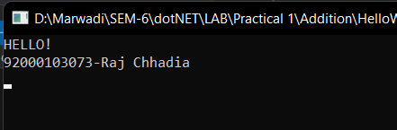

**Program 2: Write a C# Program to add 2 Numbers.**

**Code:**

using System;

namespace Addition

{

internal class Program

{

private static void Main(string[] args)

{

Console.WriteLine("Addtion of two numbers");

Console.WriteLine("Enter 1st INTEGER");

int a = int.Parse(Console.ReadLine());

Console.WriteLine("Enter 2nd INTEGER");

int b = int.Parse(Console.ReadLine());

int c = a + b;

Console.WriteLine("Answer: " + c);

Console.ReadKey();

}

}

}

**Output:**

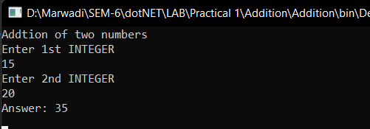

**Program 3: Write a C# Program to find maximum of 2 Numbers.**

**Code:**

using System;

namespace MaxOfTwo

{

internal class Program

{

private static void Main(string[] args)

{

Console.WriteLine("Max of two numbers");

Console.WriteLine("Enter 1st INTEGER");

int a = int.Parse(Console.ReadLine());

Console.WriteLine("Enter 2nd INTEGER");

int b = int.Parse(Console.ReadLine());

if (a > b)

Console.WriteLine("Max is : " + a);

else if (b > a)

Console.WriteLine("Max is: " + b);

else

Console.WriteLine("Both are equal");

Console.ReadKey();

}

}

}

**Output:**

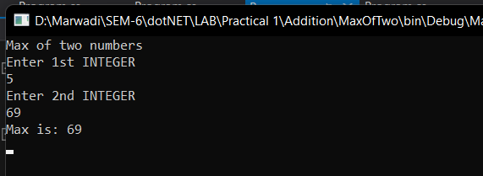

**Program 4: Write a C# Program to generate electricity bill using Else-If ladder**

**Code:**

using System;

namespace ElectricityBill

{

internal class Program

{

private static void Main(string[] args)

{

Console.WriteLine("Electricity Bill Calaculator");

Console.WriteLine("Enter number of units consumed: ");

float a = float.Parse(Console.ReadLine());

if (a > 0 && a <= 100)

Console.WriteLine("Bill amount is : " + (a * 5));

else if (a >= 100 && a < 200)

Console.WriteLine("Bill amount is : " + (a * 10));

else if (a >= 200 && a < 300)

Console.WriteLine("Bill amount is : " + (a * 20));

else if (a >= 300 && a < 400)

Console.WriteLine("Bill amount is : " + (a * 30));

else if (a >= 400 && a < 500)

Console.WriteLine("Bill amount is : " + (a * 40));

else

Console.WriteLine("Bill amount is : " + (a * 50));

Console.Read();

}

}

}

**Output:**

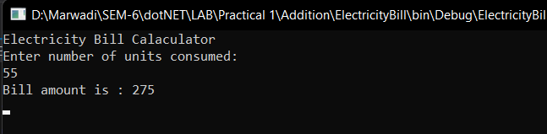

**Program 5: Write a C# Program to find the sum of first N numbers.**

**Code:**

using System;

namespace SumOfN

{

internal class Program

{

private static void Main(string[] args)

{

Console.WriteLine("Sum of n numbers");

Console.WriteLine("Enter value of n");

int a = int.Parse(Console.ReadLine());

int sum = 0;

for (int i = 1; i <= a; i++)

{

sum += i;

}

Console.WriteLine("Sum is: " + sum);

Console.Read();

}

}

}

**Output:**

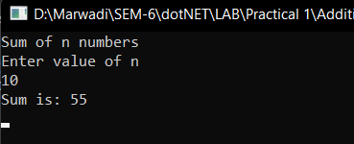

**LAB - 2**

**Program 1: Write a C# Program to check a number is Palindrome or not.**

**Code:**

using System;

using System.Collections.Generic;

using System.Linq;

using System.Text;

using System.Threading.Tasks;

namespace Palindrome

{

class Program

{

static void Main(string[] args)

{

Console.WriteLine("Palindrome checker");

Console.WriteLine("Enter the string: ");

string originalString = Console.ReadLine();

char[] stringArray = originalString.ToCharArray();

Array.Reverse(stringArray);

string reverseString = new string(stringArray);

if (reverseString.Equals(originalString))

Console.WriteLine("String is Palindrome");

else

Console.WriteLine("String is not Palindrome");

// 92000103073

}

}

}

**Output:**

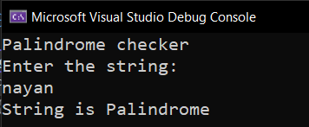

**Program 2: Write a C# Program to generate Fibonacci series up to N Numbers.**

**Code:**

using System;

using System.Collections.Generic;

using System.Linq;

using System.Text;

using System.Threading.Tasks;

namespace Palindrome

{

class Program

{

static int NthTerm(int N)

{

if ( N == 1)

{

return 0;

}

else if ( N == 2)

{

return 1;

}

else

{

return NthTerm( N-1 ) + NthTerm( N-2 );

}

}

static void Main(string[] args)

{

Console.WriteLine("Enter the number : ");

int num = Convert.ToInt32(Console.ReadLine());

Console.WriteLine(num + " Term of fibonacci is " + NthTerm(num) );

// 92000103073

}

}

}

**Output:**

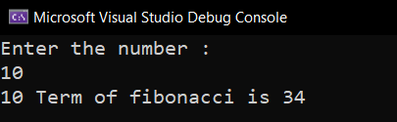

**Program 3: Write a C# program to create a calculator using Switch Case.**

**Code:**

using System;

using System.Collections.Generic;

using System.Linq;

using System.Text;

using System.Threading.Tasks;

namespace Calculator

{

class Program

{

static void Main(string[] args)

{

Console.WriteLine("Calculator");

Console.WriteLine("Enter operation (+.-,*,/): ");

string operation = Console.ReadLine();

Console.WriteLine("Enter 1st number: ");

float a = float.Parse(Console.ReadLine());

Console.WriteLine("Enter 2nd number: ");

float b = float.Parse(Console.ReadLine());

switch (operation)

{

case "+":

Console.WriteLine("Addition of two number is: " + (a + b));

break;

case "-":

Console.WriteLine("Subtraction of two number is: " + (a - b));

break;

case "*":

Console.WriteLine("Multiplication of two number is: " + (a * b));

break;

case "/":

Console.WriteLine("Division of two number is: " + (a / b));

break;

default:

Console.WriteLine("Invalid Input!");

break;

}

// 92000103073

}

}

}

**Output:**

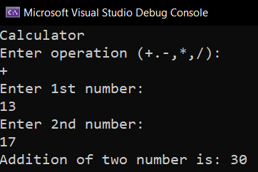

**Program 4: Write a C# Program to print a given array in reverse.**

**Code:**

using System;

class HelloWorld

{

static void Main()

{

Console.WriteLine("Enter the number of element : ");

int size = Convert.ToInt32(Console.ReadLine());

int[] numbers = new int[size];

for (int i = 0; i < size; i++)

{

Console.Write("Array[{0}] :", i);

numbers[i] = Convert.ToInt32(Console.ReadLine());

}

Array.Reverse(numbers);

Console.Write("[ " );

for (int i = 0; i < size; i++)

{

Console.Write(numbers[i] + ", ");

}

Console.Write(" ]");

}

}

**Output:**

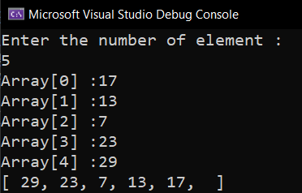

**Program 5: Create a simple C# code for the following:**

**55555**

**4444**

**333**

**22**

**1**

**Code:**

using System;

class HelloWorld{

static void Main(){

Console.WriteLine("Enter the number : ");

int number = Convert.ToInt32(Console.ReadLine());

for ( int i = 0; i < number; i++ ){

for ( int j = number - i; j > 0; j--){

Console.Write( number - i );

}

Console.WriteLine("\n");

// 92000103073

}

}

}

**Output:**

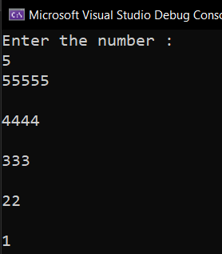

**LAB - 3**

**Program 1: Write a C# program find area of Circle, Rectangle and Square using Polymorphism.**

**Code:**

using System;

class HelloWorld1

{

static double area(int N)

{

return 3.14 *

N * N;

}

static double area(double N)

{

return N * N;

}

static double area(int N1, int N2)

{

return N1 * N2;

}

static void Main()

{

Console.WriteLine("\nArea of circle : ");

Console.Write("Enter radius : ");

int radius = Convert.ToInt32(Console.ReadLine());

Console.WriteLine("Area of circle : " + area(radius));

Console.WriteLine("\nArea of square : ");

Console.Write("Enter width : ");

double width = Convert.ToDouble(Console.ReadLine());

Console.WriteLine("Area of square : " + area(width) );

Console.WriteLine("\nArea of reactangle : ");

Console.Write("Enter width : ");

int width1 = Convert.ToInt32(Console.ReadLine());

Console.Write("Enter breadth : ");

int breadth1 = Convert.ToInt32(Console.ReadLine());

Console.WriteLine("Area of reactangle : " + area(width1, breadth1));

// 92000103073

}

}

**Output:**

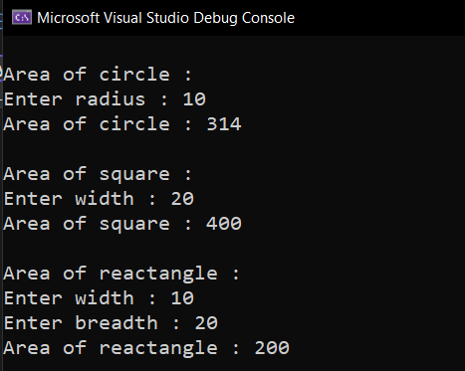

**Program 2: Consider a class Information that has data members as Name, Surname and Contact number. Let Employee and Student class inherits Information class with its own other information such as Students Semester or Employee Salary. Implement a system using Method Overriding to take input from the user for all the information and display proper output.**

**Code:**

using System;

using System.Collections.Generic;

using System.Linq;

using System.Text;

using System.Threading.Tasks;

namespace Information

{

class Program

{

static void Main(string[] args)

{

Student s1 = new Student();

Employee e1 = new Employee();

Console.WriteLine("Enter your choice: ");

Console.WriteLine("1. Student");

Console.WriteLine("2. Employee");

int choice = int.Parse(Console.ReadLine());

switch (choice)

{

case (1):

s1.getData();

s1.putData();

break;

case (2):

e1.getData();

e1.putData();

break;

}

Console.ReadKey();

}

}

class Information

{

public string name;

public string surname;

public int number;

public void getData()

{

Console.WriteLine("Enter the first name: ");

name = Console.ReadLine();

Console.WriteLine("Enter the surname: ");

surname = Console.ReadLine();

Console.WriteLine("Enter the contact number: ");

number = int.Parse(Console.ReadLine());

}

}

class Employee : Information

{

public int salary;

public void getData()

{

base.getData();

Console.WriteLine("Enter the employee salary: ");

salary = int.Parse(Console.ReadLine());

}

public void putData()

{

Console.WriteLine("Name: " + name);

Console.WriteLine("SurName: " + surname);

Console.WriteLine("Contact Number: " + number);

Console.WriteLine("Salary: " + salary);

}

}

class Student : Information

{

public int semester;

public void getData()

{

base.getData();

Console.WriteLine("Enter the semester number: ");

semester = int.Parse(Console.ReadLine());

}

public void putData()

{

Console.WriteLine("Name: " + name);

Console.WriteLine("SurName: " + surname);

Console.WriteLine("Contact Number: " + number);

Console.WriteLine("Semester: " + semester);

// 92000103073

}

}

}

**Output:**

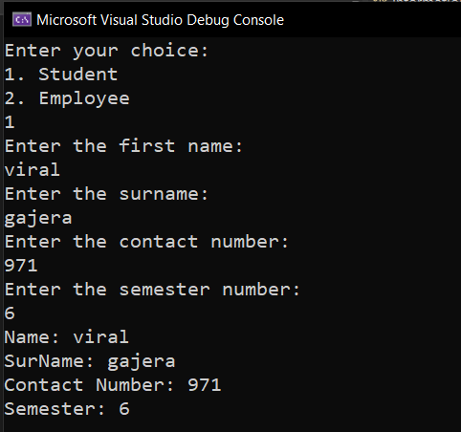

**Program 3: Consider a class Apartment that has data members as Apartment number and balcony type. Implement a system that has 3 classes as 1bhk,2bhk and 3bhk such that it does not allow to create any other classes above 3bhk. Also implement inheritance in such a way that 1bhk will have Rectangular Balcony and all other flats have Rounded Balcony (Use Sealed Class).**

**Code:**

using System;

namespace Apartment{

internal class Program{

private static void Main(string[] args){

OneBHK f1 = new OneBHK();

f1.welcome();

f1.display();

f1.balcony();

TwoBHK f2 = new TwoBHK();

f2.welcome();

f2.display();

f2.balcony();

ThreeBHK f3 = new ThreeBHK();

f3.welcome();

f3.display();

f3.balcony();

Console.ReadKey();

}

}

public class Flat{

public void welcome(){

Console.WriteLine("Welcome to Beautiful Apartment... Viral Gajera");

}

public virtual void display(){

Console.WriteLine("Not ready yet...");

}

public virtual void features(){

Console.WriteLine("Not ready yet...");

balcony();

}

public virtual void balcony(){

Console.WriteLine("Not ready yet...");

}

}

public class OneBHK : Flat{

public override void display(){

Console.WriteLine("This is 1 BHK flat");

}

public override void features(){

Console.WriteLine("\tFeatures...");

balcony();

}

public override void balcony(){

Console.WriteLine("\tBalcony: Rectangular\n");

}

}

public class TwoBHK : OneBHK{

public override void display()

{

Console.WriteLine("This is 2 BHK flat");

}

public override void features(){

Console.WriteLine("\tFeatures...");

balcony();

}

public override sealed void balcony(){

Console.WriteLine("\tBalcony: Circular\n");

}

}

public sealed class ThreeBHK : TwoBHK{

public override void display(){

Console.WriteLine("This is 3 BHK flat");

}

public override void features(){

Console.WriteLine("\tFeatures...");

balcony();

}

}

}

**Output:**

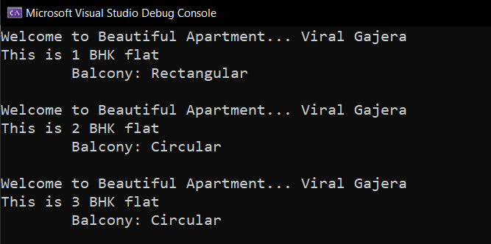

**Program 1: Write a C# Program to print “Hello World”.**

**Code:**

**Output:**

**Program 1: Write a C# Program to print “Hello World”.**

**Code:**

**Output:**

**Program 1: Write a C# Program to print “Hello World”.**

**Code:**

**Output:**

**Program 1: Write a C# Program to print “Hello World”.**

**Code:**

**Output:**